Use Case 24: Search Diffuse Sources - suggestion to change layout

In the original layout the layer list was designed as radio buttons placed at the maps left side and with detailed information about selected layer below (Figure 1 and Figure 2).

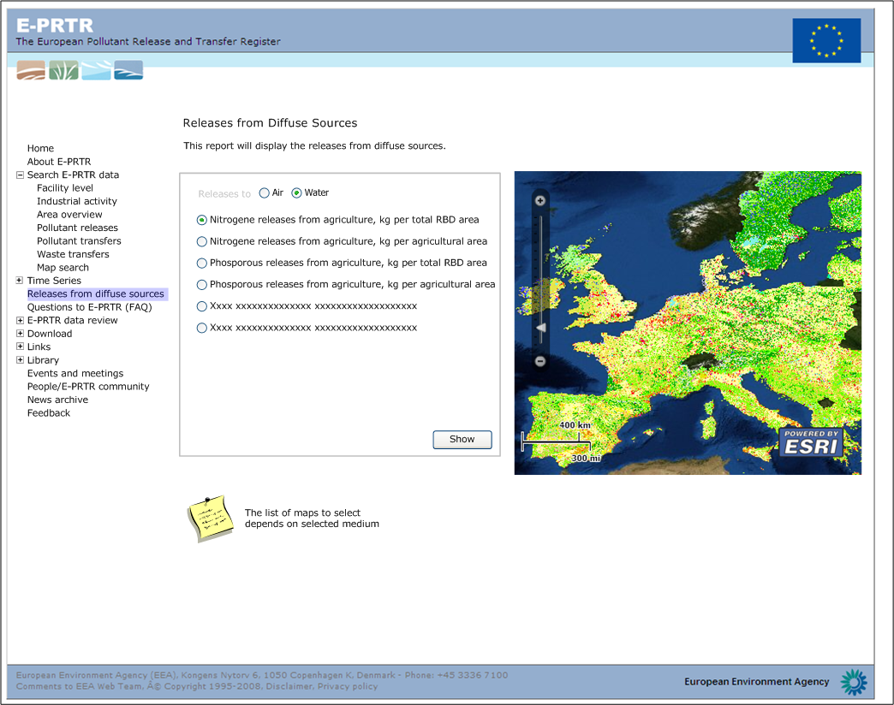
Figure 1: Diffuse sources map - original layout suggestion.

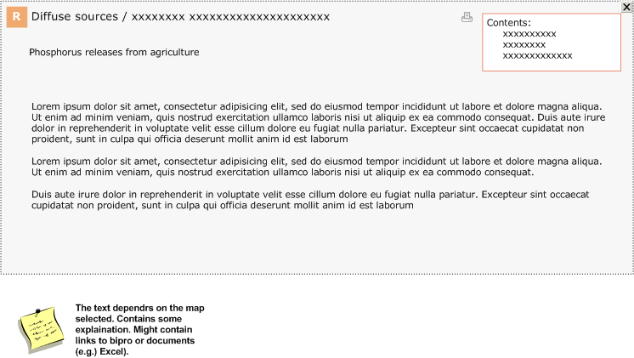
Figure 2: Detailed layer information originally suggested to be placed below map.

Our new suggestion is to use the layer list as we know it from the other maps (Figure 3).

The layers will be grouped by water and air. Furthermore the river basin districts will be available from the layer list (in the other maps we have it as a background layer combined with satellite imagery)

Technically two mapservices will be set up – one for water and one for air. Each service will contain the relevant layers.

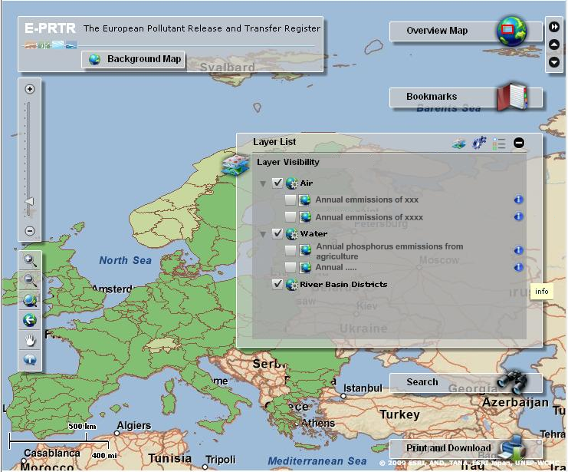
Figure 3: Layout suggestion for diffuse sources map. The layers can be switched on/off in the layer list and are grouped by water and air. Next to each layer an info button opens a new window with layer details. This is the expanded version of diffuse sources map. The only difference from the embedded map is the banner in the left corner.

Next to each layer in the list we suggest to add an info button. Pressing this will open a new window in style with facility detail popup (Figure 4). The window will contain information about the layer.
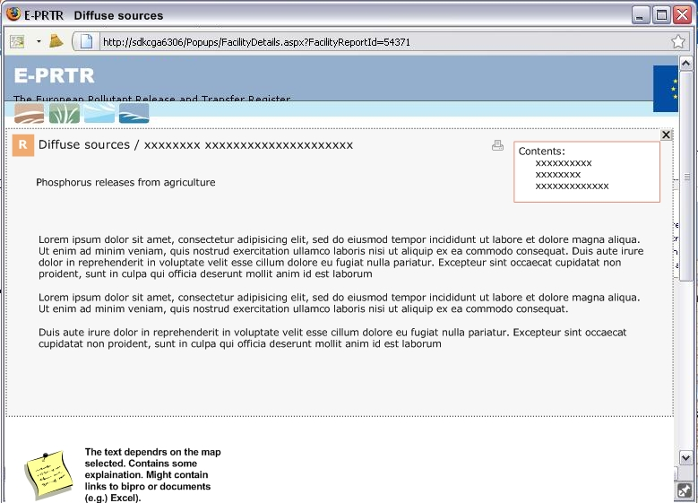
Figure 4: The layer details are opened in a new pop up window after pressing info button.

Point sources

In the technical specification of diffuse sources (use case 24) it says that" A layer presenting relevant facilities (identified by main activities) can be added if relevant".

To implement this we suggest to have one facility layer in the diffuse sources layer list. This layer should be updated to show the facilities relevant for the current shown diffuse map.

We would need to now for each diffuse source map the

- medium,
- main activity
- year
- pollutant

and be sure that all facilities fulfilling the criteria are indeed relevant. If no relevant facilities exists for a given diffuse source map, none will be shown.

In the layer list only one diffuse source layer would be switched on at a time and this layer would determine the facility layer where clause i.e. which facilities that are shown when turning on the point sources map.

This approach requires that we switch of all other diffuse sources layers than the one last chosen. But since the layers are rasters/polygons, this should present no problem – the user would not look at more than one at a time anyway.

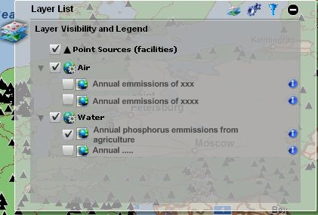
Figur 5: The point sources layer will be updated depending on which diffuse map that is turned on. In this layer list the RBD layer has been removed and is placed with the background layers.

